[Study in Korea Education Fair for Colleges 2022]
It is our pleasure to announce that NIIED will hold “2022 Study in Korea Education Fair for Colleges” for international students.
- Name of the event: 2022 Study in Korea Education Fair for Colleges
- Date: Aug 23rd (Tue) ~ Sep 1st (Thu)
3. Introduction of main contents
- Studying in Korea, scholarship programs, information about Korean Universities, online application, online consultation, Live Chat, Live streaming
4. Participating universities: 34 universities
5. How to access and join the online education fair (Please see the attachment.)
- Visit the Study in Korea website (www.studyinkorea.go.kr) to select the online education fair link.
- Complete the registration and visit the website during the online education fair.

<Attachment>
How to register“2022 Study in Korea Education Fair for Colleges”
- Visit the Study in Korea website“www.studyinkorea.go.kr”
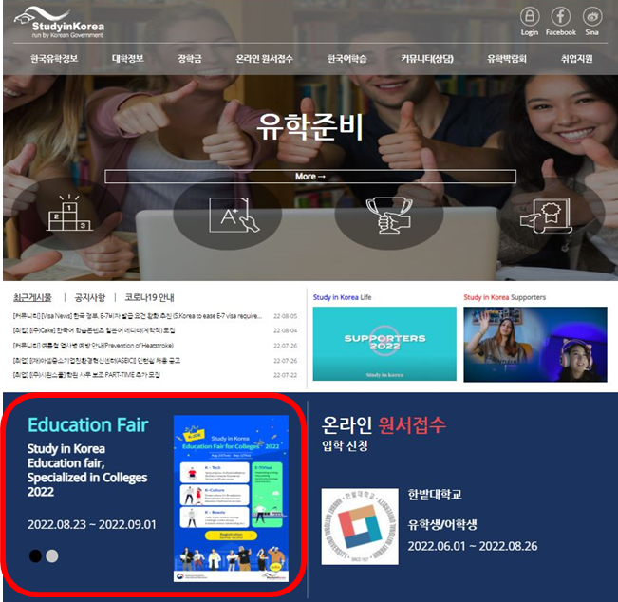
- Click “2022 Study in Korea Online Education Fair for Colleges”

- Click “Registration” to join the Fair.
- Please visit the education fair page during the period of Aug 23rd(Tue) ~ Aug 1st(Thu).

